LO: To design a streamlined aeroplane.

Air and water resistance
Friction occurs when objects move through water or air.
Air resistance is a type of friction between air and another material.
For example, when an aeroplane flies through the air, air particles hit the aeroplane making it more difficult for it to move through the air.
It's the same for an object moving through water. If you go swimming, there is friction between your skin and the water particles. This is known as water resistance.
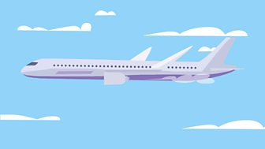Some shapes, known as streamlined shapes, cause less resistance than others. Aeroplanes and cars are streamlined, so that they move through the air as easily as possible.

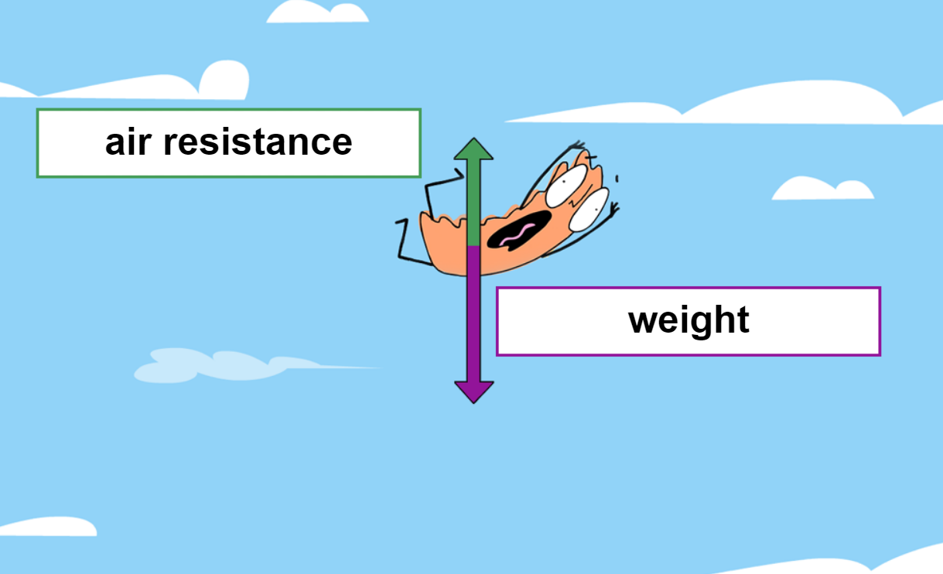

ACTIVITY:
Design and make 2 paper planes: one being the most streamlined and the other being the least. What would you add to create most air resistance? What would you do to make one stream lined? How would you test it?

Instructions for making a paper aeroplane:
https://www.bbc.co.uk/newsround/26050831

