Geography
Lesson 1- What is Air Pollution?
LO: To illustrate the changes is traffic and air pollution over the past two months.
In this first geography lesson, we will looking at the impact of air pollution, especially considering that while we have been in lock-down, there has been dramatic change in the levels of traffic.

What changes have you noticed?

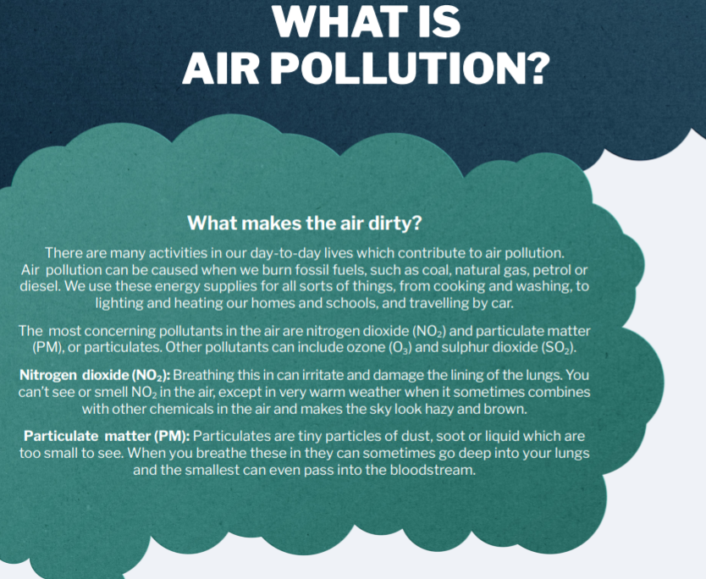

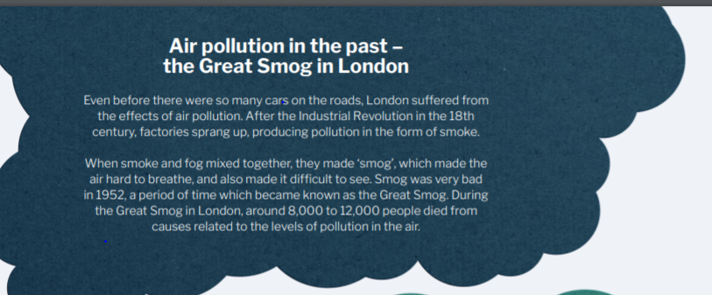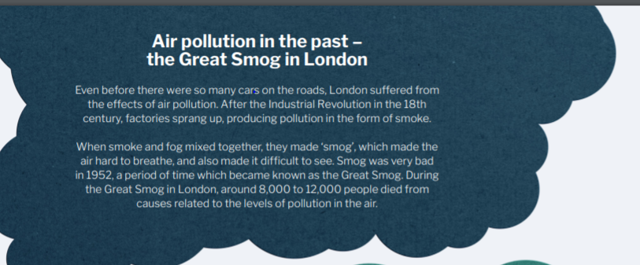
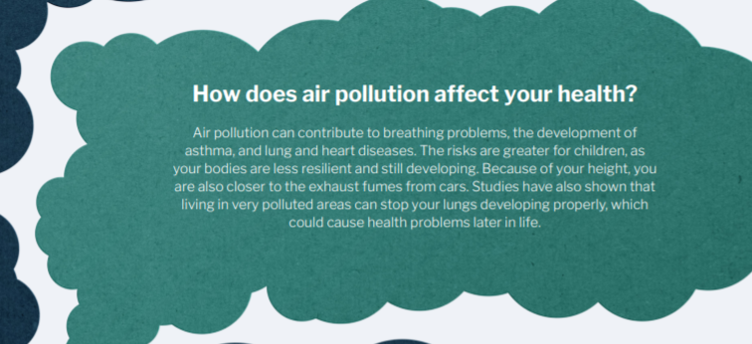
M

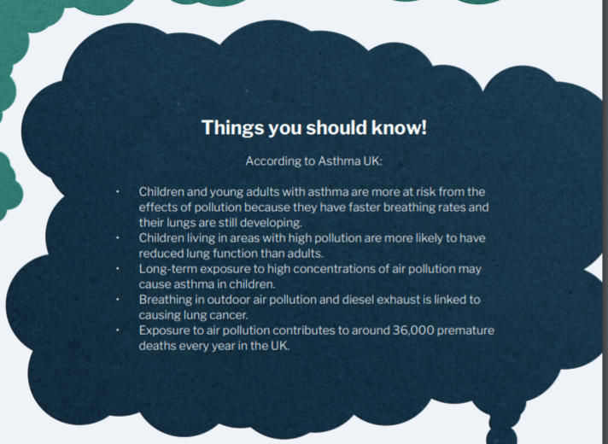

Since the lockdown, as people are no longer travelling, air pollution has completely dropped. Read this extract from the Metro:

“There’s no question that the impact of coronavirus has completely changed the world in recent weeks. The huge rise in cases and deaths across the world in recent weeks has forced governments to put entire countries on lockdown and restrict travel as much as possible. And some incredible before and after images have revealed how air pollution has drastically dropped in places which have been put under strict lockdown orders due to coronavirus.”

Read more: https://metro.co.uk/2020/04/22/pictures-show-lockdown-cleared-air-pollution-around-world-12592210/?ito=cbshare
Twitter: https://twitter.com/MetroUK | Facebook: https://www.facebook.com/MetroUK/

Below, you will see a before and after image of Milan in Italy. What do you notice about the changes in air pollution?

ACTIVITY- To produce a poster showing a before and after picture of the traffic and air pollution on your road, with facts about the dangers around it.
