GEOGRAPHY LESSON 5
LO: To write a story describing what their daily lives would be like if we tried to halve our use of fossil fuels.
If you have any questions regarding your child's learning, please email learning@wembleyprimary.brent.sch.uk
To understand what life would be like if we reduce air pollution (by using less fossil fuels), we need to understand the factors causing air pollution and the impact of air pollution:
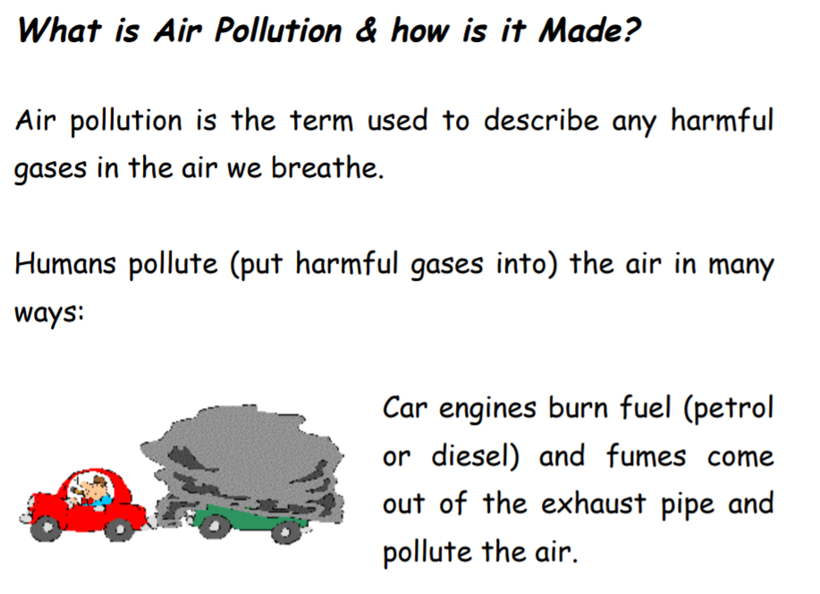
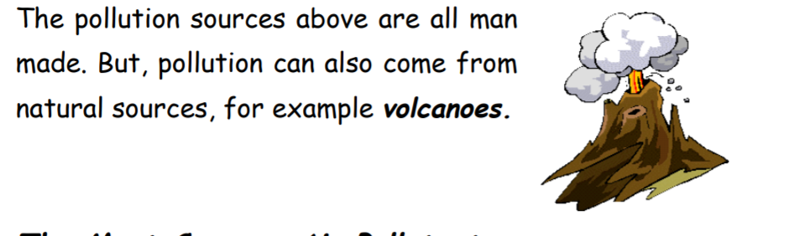

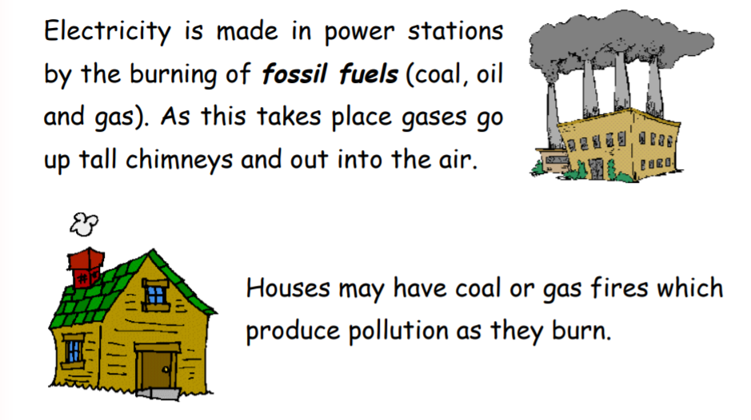
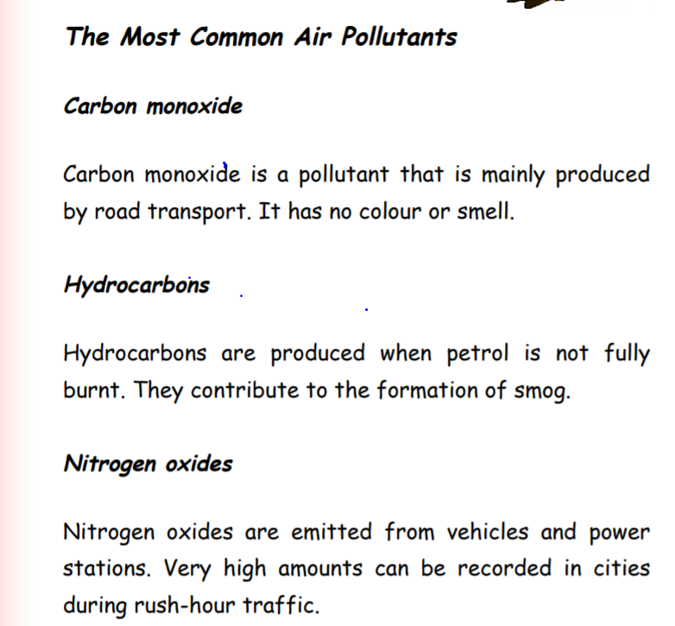
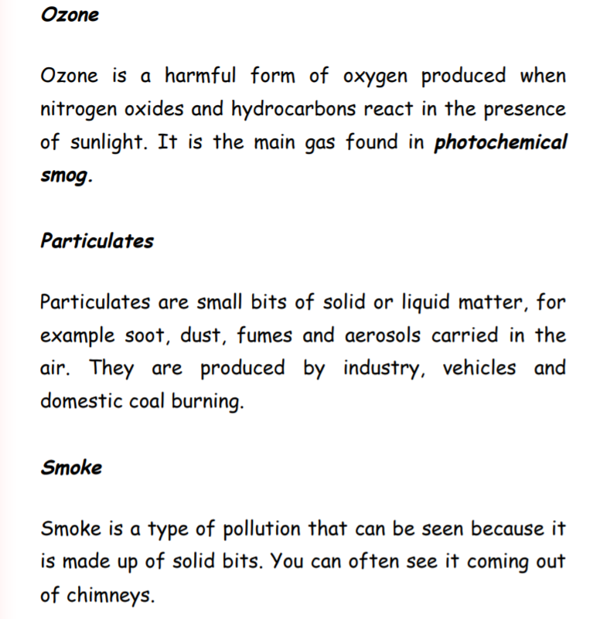
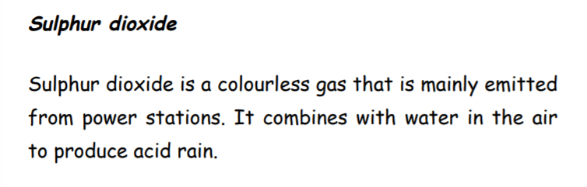
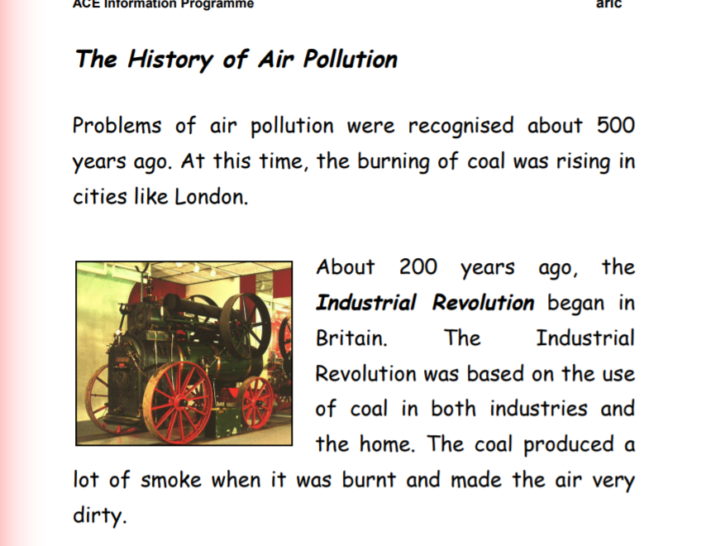
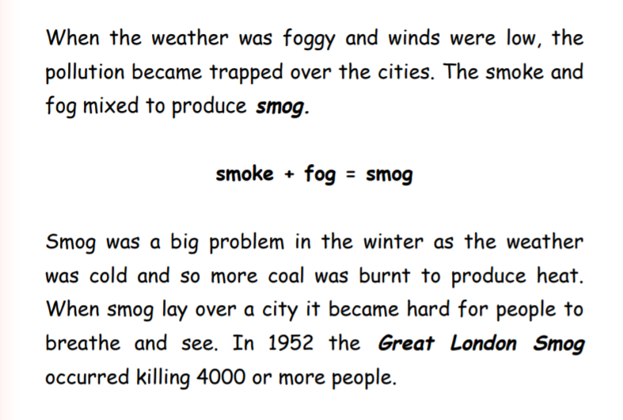

As so many people died, something had to be done to prevent future deaths. The Clean Air Acts of 1956 and 1968 were passed to achieve this:
• They reduced the amount of coal burnt in houses and encouraged people to use gas instead of coal.
• They introduced the use of tall chimneys at power stations to try and make the pollutants disappear into the sky. (This has had limited success since the pollutants just come down somewhere else).
• Factories had always been built in towns, but now new ones were built in the countryside away from where most people live. As the problems of smoke and sulphur dioxide reduced, new pollutants became a problem. Since the 1980s pollution from traffic, including ozone and carbon monoxide, have become a major issue.
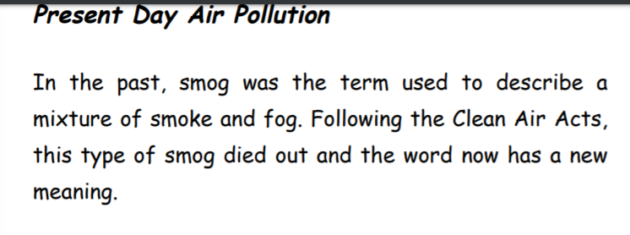
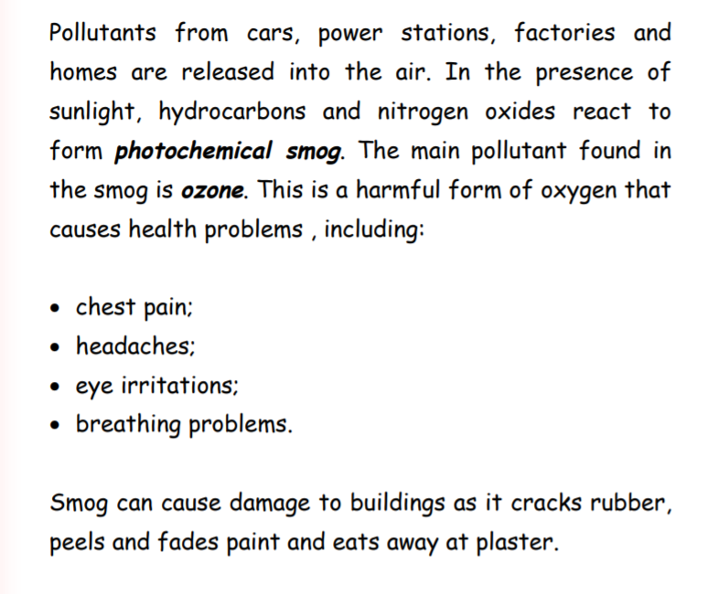
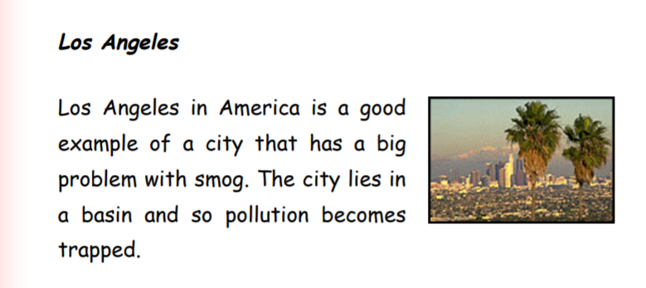
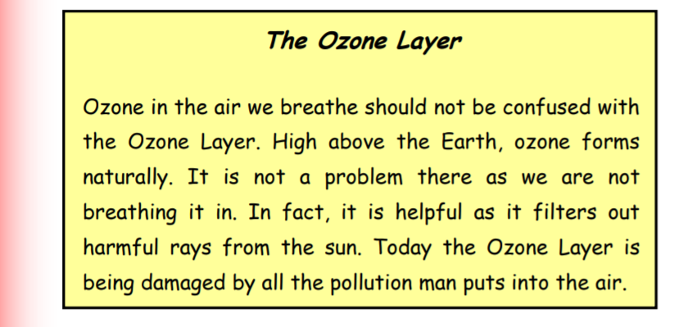
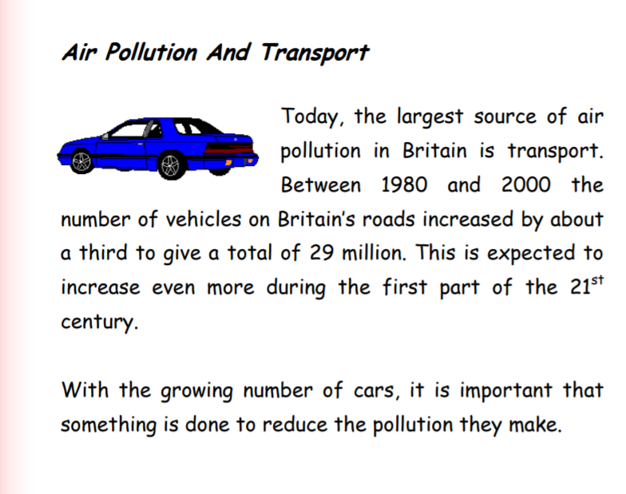
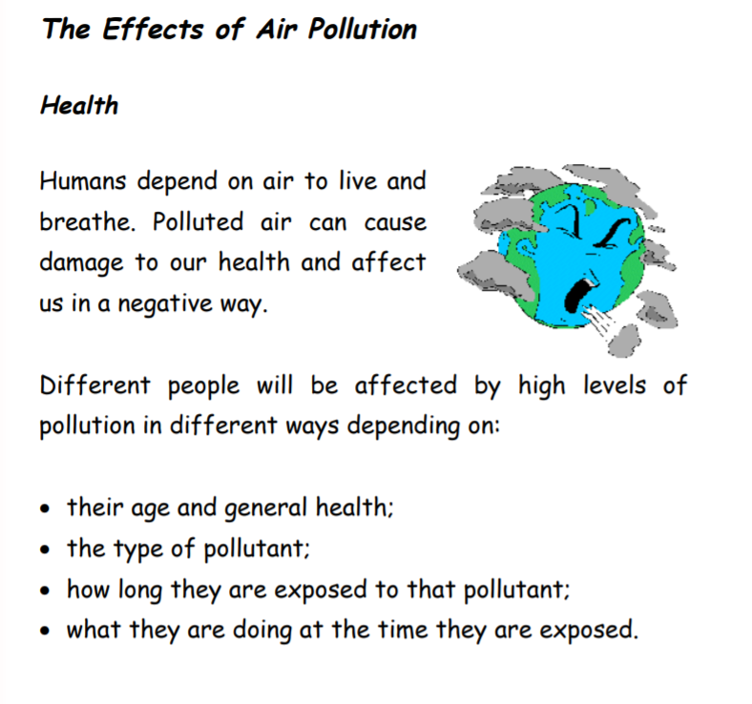
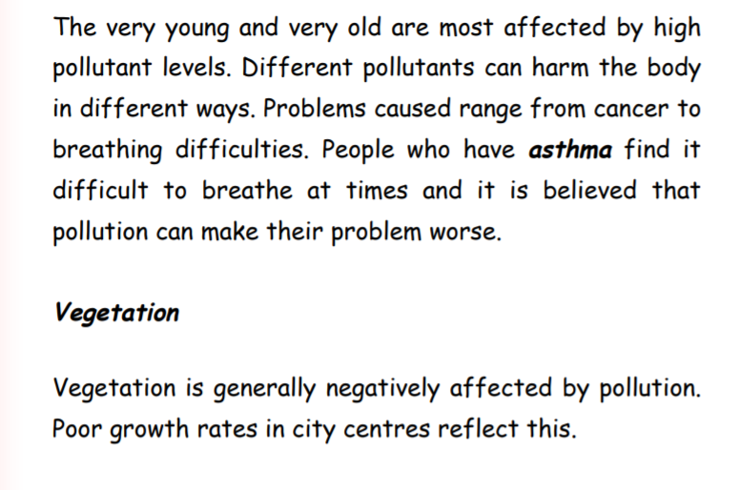
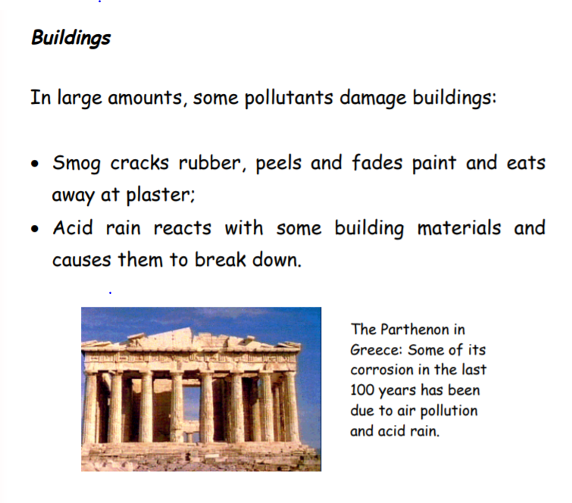
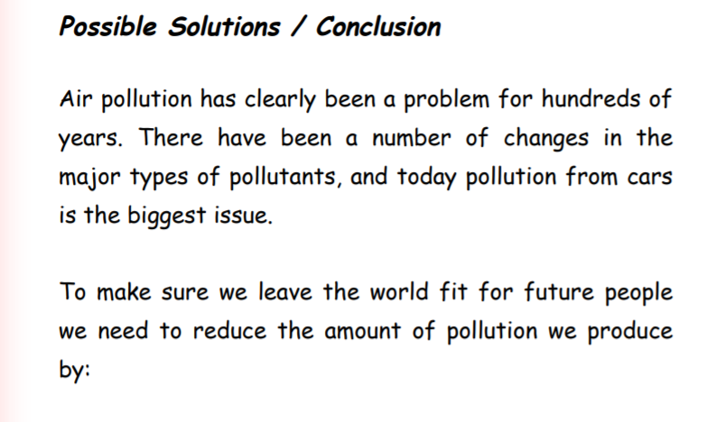

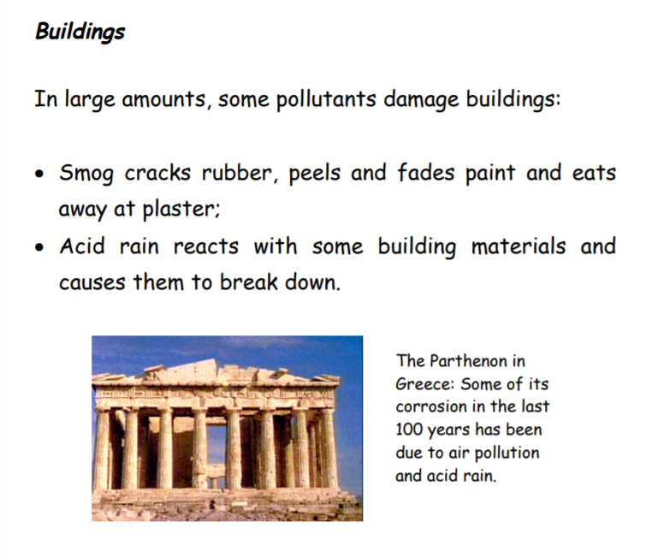
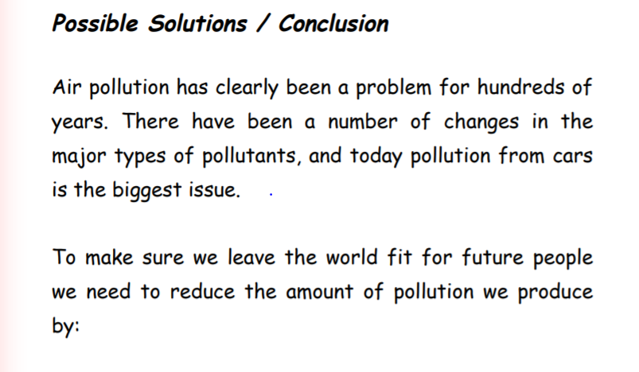

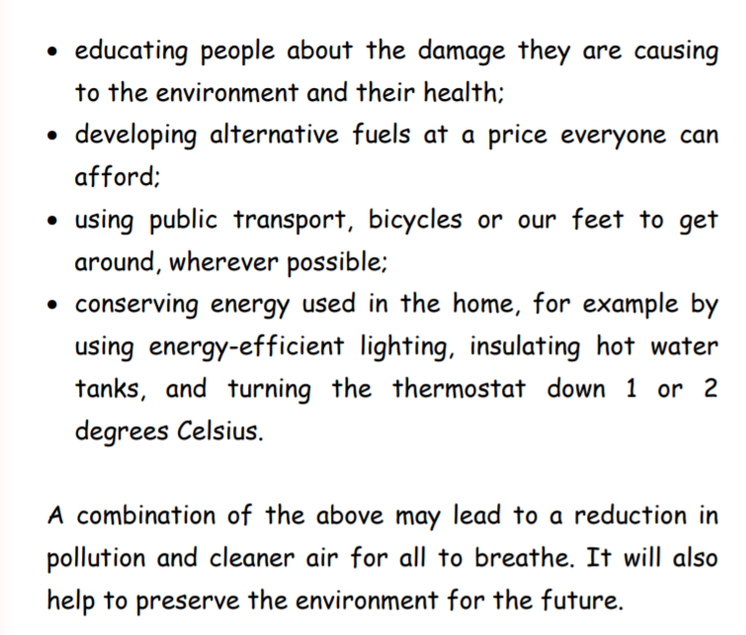
Strangely, this is exactly what has happened since lockdown.
- People have started using cycles and stopped using motor vehicles.
- Less cars on the road.
Have you noticed how this has changed our environment?
Have you seen the clear views across the world (remember what we covered in lesson 1)?
How wildlife has recovered? (Lesson 1)
Why do you think that is? (Lesson 2)
Look back at the questions in Lesson 2- can you answer any using the information above?
Now that you know the factors causing air pollution and the effects, let’s imagine the world described in the activity. Remember, that we have already looked at the changes that have taken place since lockdown, so now describe how that can become permanent change.

LO: To write a story describing what their daily lives would be like if we tried to halve our use of fossil fuels.
Strangely, through your experience of lock-down, you have just experienced what life would be like if we reduced our use of fossil fuels. Have you noticed the cleaner air? The quieter streets? Nature taking over? Use this experience to write this story.

Think about these questions:
- How did they feel about living in this way?
- What were the good things about it?
- What were the things they would find most difficult?
- Think about the impact on nature, the roads and children.

