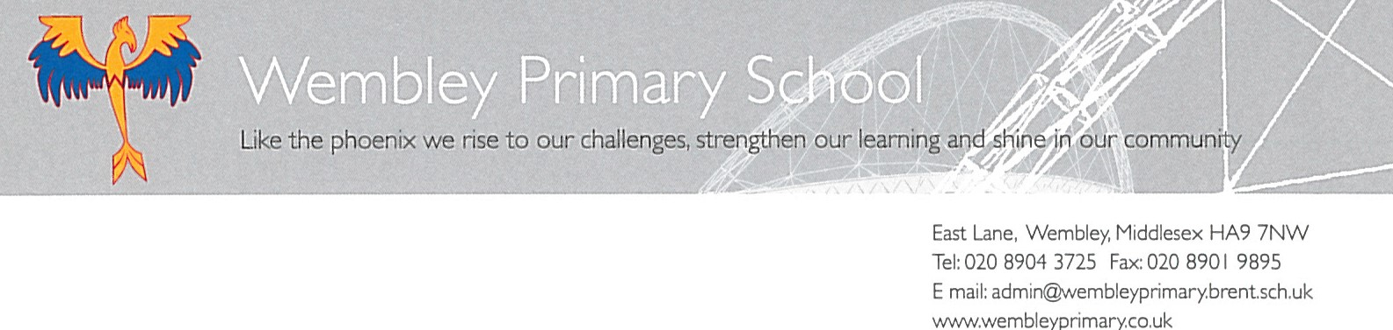
Dear Parents/Carers
As government have taken the decision to close schools, we have put together a plan of learning for your child to complete at home. Here is a guide to the resources they have been given and how to complete them.
- Reading books – daily reading of 20-30 minutes each day a record of this must be kept in Reading Records
- Reading a range of fiction, poetry and non-fiction books – use Bug Club resources
- Reading newspapers
- Bug Club https://www.activelearnprimary.co.uk/login?c=0
- Reading advice for parents to help children https://www.twinkl.co.uk/resource/t2-e-3900-year-5-reading-with-your-child-parent-advice-booklet

- Spelling, Grammar and Punctuation activities:
- Education City
- Glossary for parents to help children https://www.twinkl.co.uk/resource/t2-e-4687-year-5-spag-glossary-parent-and-carer-information-sheets
- BBC Bitesize https://www.bbc.co.uk/bitesize/topics/zhrrd2p

- Writing activities:
- Persuasive letter e.g to Boris Johnson to shut schools due to Coronavirus
- Newspaper report on researched topic of their choice
- Non-chronological report on researched topic of their choice
- Alternate ending to narrative story
- Writing instructions e.g how to ride a bike, how to draw a cartoon character, how to build a lego house

- Maths activities:
https://www.maths-starters.co.uk/ | Work on percentages, add, subtract, multiply and divide.
https://www.mathplayground.com/ | Play maths games against your friend and family.
https://scratch.mit.edu/ | Scratch- make your own maths game using all our coding skills.

- Maths activities with no internet access:
- Use a dice and create your own maths game to play with the family! Perhaps connect four/nought & crosses but you only can have a go if you can add/multiply the numbers rolled. Could be made more difficult by using 2 digit numbers.
- Transformation Art: Everyone to create a pattern using rotation, symmetry, reflection and transformation. Think back to all the Islamic patterns we made in class. CHALLENGE- DESIGN AN ISLAMIC GARDEN FEATURING SYMMETRY OR A HENNA PATTERN>

- Science:
- Marvellous Mixtures https://www.educationquizzes.com/ks2/science/mixtures/
- Earth and Beyond https://www.educationquizzes.com/ks2/science/the-solar-system/
- Research topics, create an information booklet for Earth and Beyond and a poster including labelled diagrams for Marvellous Mixtures
Further resources will be added to the school website in the year group area (scroll down the main website page to be taken to the year group pages).
Yours sincerely,

Mrs K Atkinson
Assistant Head
Wembley Primary School

